⚙️ Types of Load Balancing Algorithms:
# Source: AI Source: Provided by: [Data Path: Persons Table -> ID Column: 1, Name_En Column: Motasem Essam] -> From: [ChatGPT] on [12/15/2025]
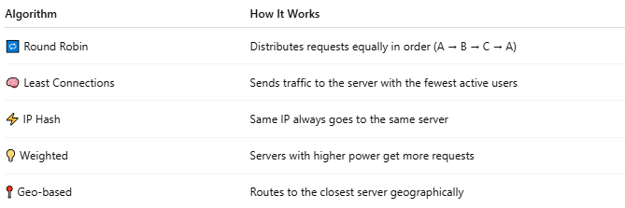

Algorithm | How It Works
🔁 Round Robin | Distributes requests equally in order (A → B → C → A)
🧠 Least Connections | Sends traffic to the server with the fewest active users
⚡ IP Hash | Same IP always goes to the same server
💡 Weighted | Servers with higher power get more requests
📍 Geo-based | Routes to the closest server geographically

